PORT WRITERS INC
OPEN LITERARY COMPETITION 2020
TERMS & CONDITIONS
Short Fiction: to 2500 words
Non-Fiction: to 2500 words
Poetry: to 32 lines
The competition opens 30 March 2020 and closes at midnight on 30 June 2020.
Winners will be notified via email on Saturday 15 August and awarded on Saturday 22 August 2020 at the Port Writers Inc meeting held from1 pm at the Rotary Community Centre, Hastings River Drive, Port Macquarie, NSW or by post if social distancing is still in force.
All entries must be paid for and accompanied by a completed entry form.
Entry submission: by email to portwritersinc@gmail.com
with subject heading: 2020 competition
Entry fee: $5.00 per entry or $4 per entry for 5 or more. Payment details on the entry form
- Entries must be original, unpublished either in print or online, not have received an award in another competition, and not be under consideration elsewhere from the time of entry in this competition until the official announcement of winners. Any work that has appeared in the public arena, including self-publishing and social media, is considered published.
- Entrants must be over 18 years, Australian citizens or permanent residents of Australia.
- A limit of 3 entries in each category is permitted per entrant for a total of 9 entries.
- Entries which infringe on the intellectual property rights of any third party, contain any objectionable content, profanity or are potentially insulting, inflammatory or defamatory will be ineligible for judging. Entrants will be notified but entry fees will not be returned.
- The decisions of the judging panel is final and no correspondence will be entered into concerning award decisions.
- Not all prizes may be awarded.
- Submissions exceeding the word count limit will be disqualified.
- Entrants retain the copyright of any works submitted.
- Entries to be formatted as follows:
– Document size A4 saved as Microsoft Word .DOC or .DOCX
– Font: Times New Roman 12 point
– Line spacing: single spaced
– Paragraphs: no spacing before or after, first para no indent, 5 mm first line indent thereafter
– Margins: 2 cm all-around
– Title and Page number to be in the header of each page
– Author’s name must NOT be visible on the document including the document properties.
Example document format below (It makes it easier for us if you get the formatting on the spot but if you get in a tangle with it, don’t worry – you will not be disqualified)
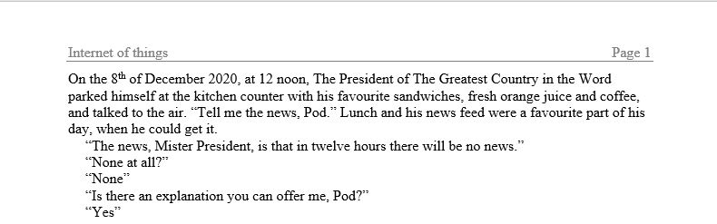
www.portwriters.com.au
www.facebook.com/portwriters portwritersinc@gmail.com

